**EXCEL ASSIGNMENT NO.7**

1. **Using Insert Function, give examples of any function available in the different dropdowns present in the function library. For example, AutoSum, Recently Used, Text, Date & Time, etc.**

When you click on Formula Tab in Excel and click on ‘Insert Function’ an insert function dialog box appears using which we can browse different function/formula available in Excel to manipulate data. We can browse the function by writing the description what actually want get done using the function or browse by category. There you will see different category in the drop down and you select one, all function that falls in particular category will appear in below select function list. If you click on the function, you can see the description of particular function just below the function list box of what the function does. Once you select the function and click ok, the Function Argument dialog box will appear where we have to give required argument to a function by selecting the cell range and click on. At the last the function will be inserted in selected cell

For example:

* In most recently used category the function that are used quite often appear you can select function and follow steps mentioned above to insert the function.

VLOOKUP (lookup_value, table_array, col_index_num, [range_lookup])

1. lookup_value- The value that to be searched
2. table_array- The array of data is to be searched for the lookup_value
3. col_index_num- An integer specifying the column number of the supplied table_array that you want to return value from

* Auto Sum:

It include the function like SUM (), AVERAGE(), MIN(), MAX() that calculate the sum(total),average, maximum, and minimum out of selected range of data.

* Text:

CONCAT(), the concat function is used for concatenation of two or more strings in excel.

* Date & Time:

MONTH(). the month function return the month number 1(January) to 12(December)

1. **What are the different ways you can select columns and rows?**

**To select adjacent rows and columns:**

* Left Click on the row/column reference you want to select.
* Press and Hold ‘Shift’ key.
* And select adjacent rows/column using arrow keys or by dragging the mouse.

**To select non-adjacent rows and columns:**

* Left Click on the row/column reference you want select.
* Press and Hold ‘Ctrl’ key.
* Select the non-adjacent rows/columns by left click on their particular reference or by dragging mouse

1. **What is AutoFit and why do we use it?**

In Excel by default each cell in the sheet have equal width and height or equal dimensions but the data we write in that cells can be lengthy and after writing the lengthy data in the cell, data is not properly visible some of character of data is not visible. To overcome this problem, we use Auto-Fit. Auto-Fit feature in Excel adjust the height and width of rows and column in manner that data present in the sheet fits in each cell and properly visible.

Shortcut for Auto-Fit: ‘**Alt+H+O+I**’

Select the data range and press the shortcut key.

1. **How can you insert new rows and columns into the existing table?**

* Select the cell whose above or below you wish to insert the row or whose left or right you wish to insert a column.
* Now ‘Right Click’ a list of function will appear.
* Click on ‘Insert’.
* Then it will ask what you want insert row or column and where you want to insert, you

need to specify the position and according to that select the option.

The above steps are illustrated in the figure given below.

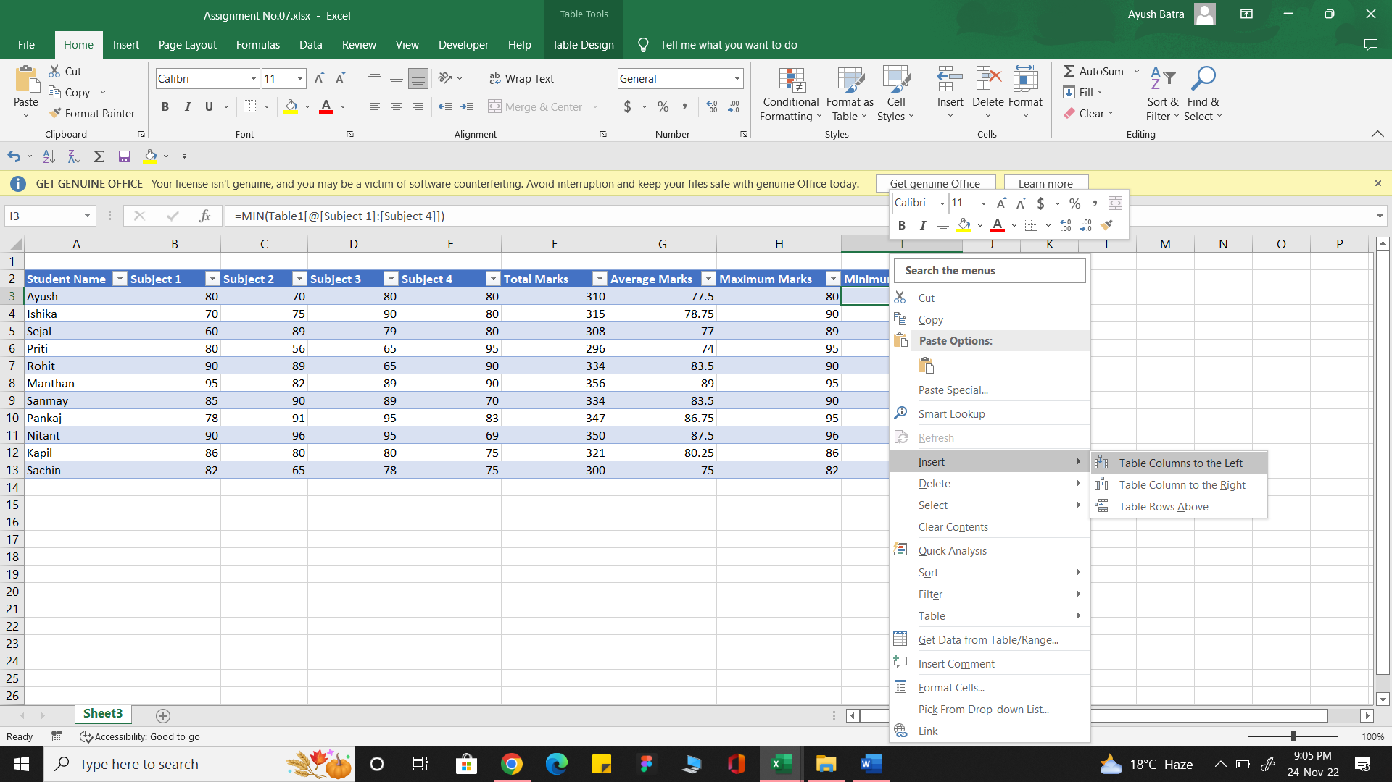

1. **How do you hide and unhide columns in excel?**

**To hide the rows and columns:**

* ‘Right Click’ on row or column refence you wish to hide.
* The list of function appears and at second last there is ‘Hide’ option given click on it.

Shortcut: ‘Ctrl+9’ (Select the cell of row or column or row/column reference you want to hide)

**To Unhide the rows and columns:**

* To unhide just again ’Right Click’ at same place.
* From the list of function at last click on ‘Unhide’ option.

Shortcut: ‘Ctrl+Shift+9’

1. **Create an appropriate table within the worksheet and use different functions available in the AutoSum command.**

The table for student and their marks in different subject is created and various AutoSum function are used such and total, average, min and max. To get total marks, average marks, maximum marks, and minimum marks respectively scored by each student.

Excel File:

(https://github.com/Ayush-Batra04/Excel-Assignment/blob/main/Assignment%20No.07.xlsx)